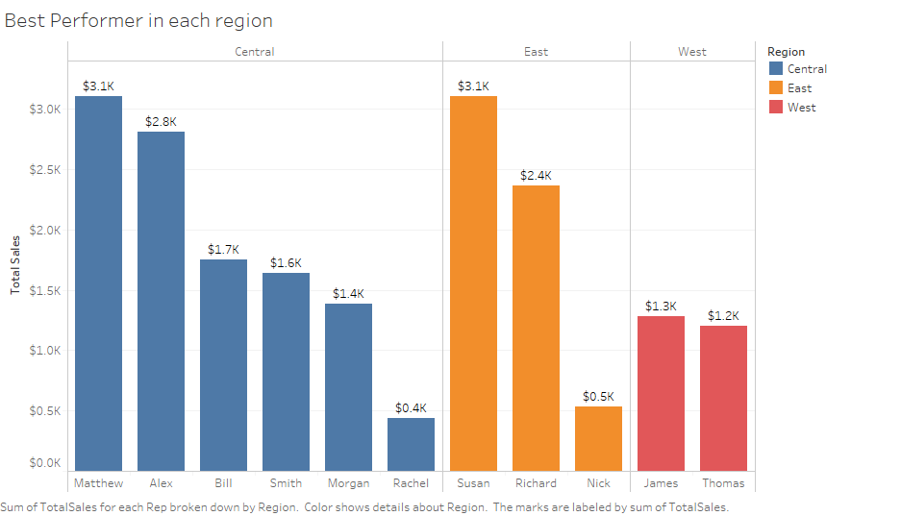**Annual Report of OfficeSupplies**